Welcome to Nous.

We have provided below documentation with screen shots to enable you to enter timesheet.

On the Nousintranet site ( Bhive) , Please select the quick link Entity Common Applications. 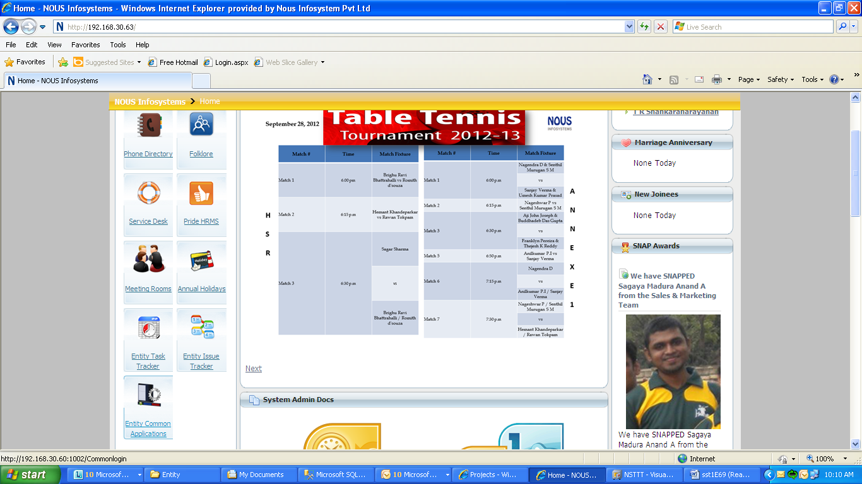

You will be taken to a login screen.

Please use the Login id given to you at the time of joining. Both Login and password are case sensitive.

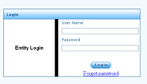

On successful login, you will see the screen given below

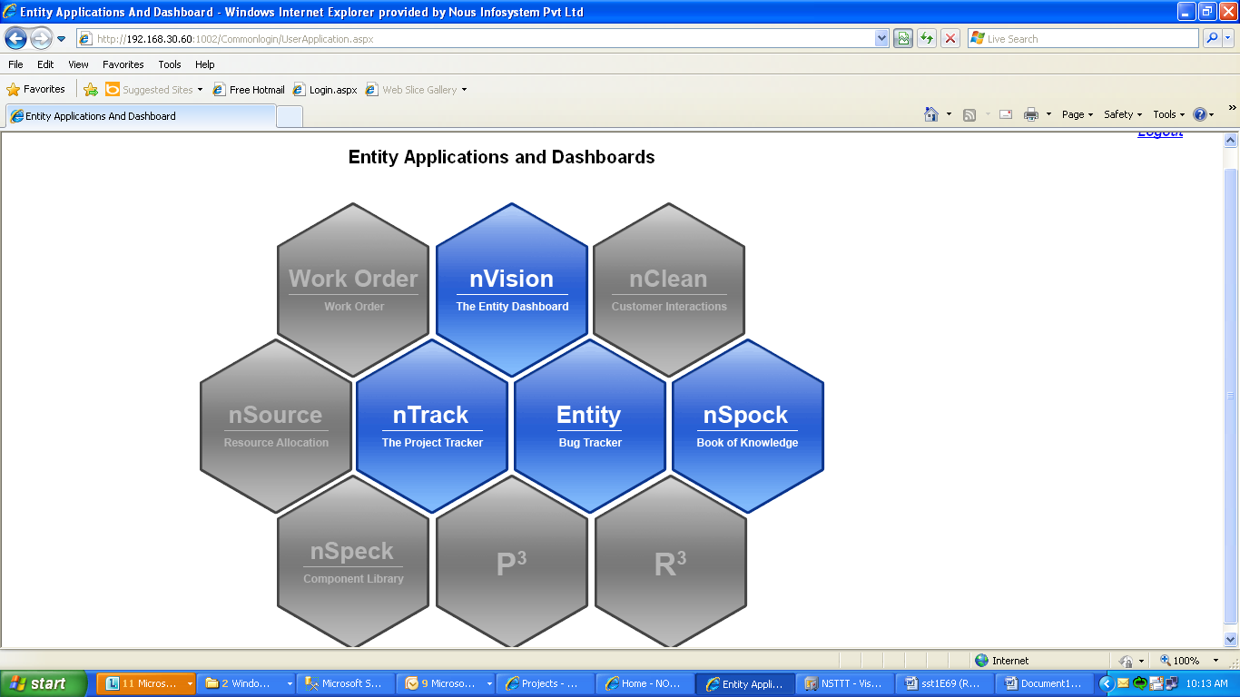

Select nTrack , The Project Tracker to enter your timesheet.

Every project is identified by a project code. If you have just joined and have not been allocated to any project as yet , you will belong by default to the Nous Acquisition Talent Pool , N-P-R. You will see the screen given below.

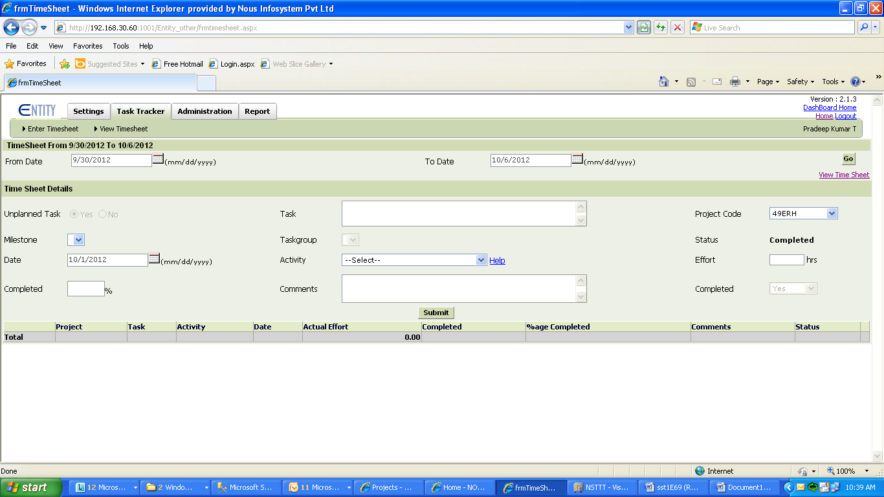

At the end of the day, please enter the task you have performed for the day and select the N-P-R code.

By default, Date field shows the current date. If you are entering timesheet for any day other than today, please change the date using the calendar.

Please also select the activity type and enter the effort hours for the activity as given in the screen below. Press submit. The entered record will appear below.

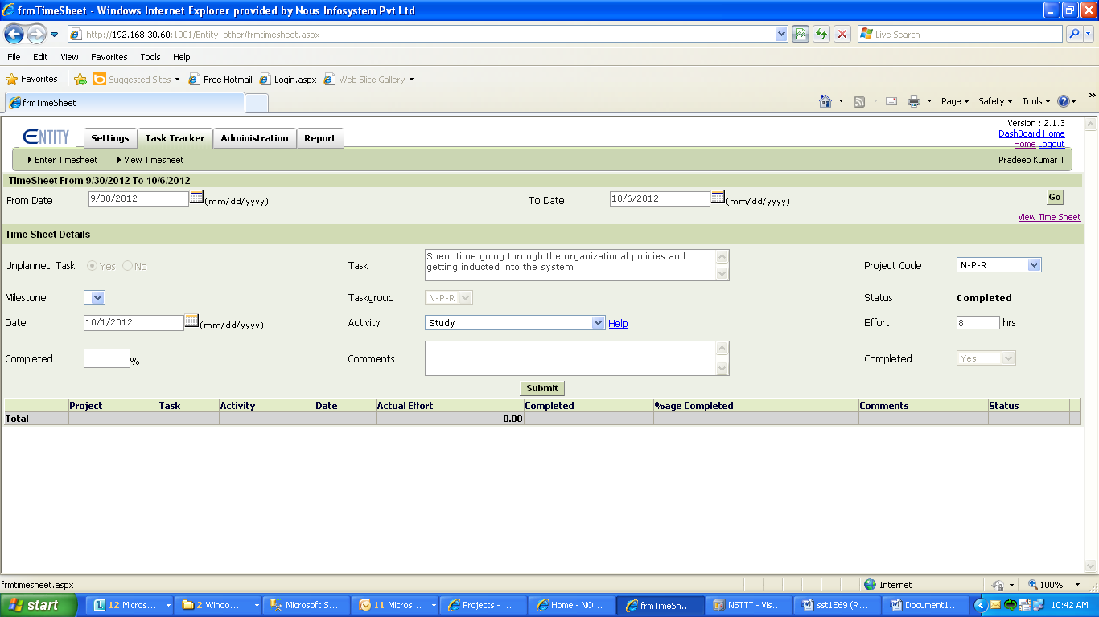

If you have been assigned to a project, request the project manager or program manager to give you access to the task tracker application of that project.

Change password.

Use the change password option(screen given below) to change your password as soon as you login for the first time. Please select a password with minimum six characters.

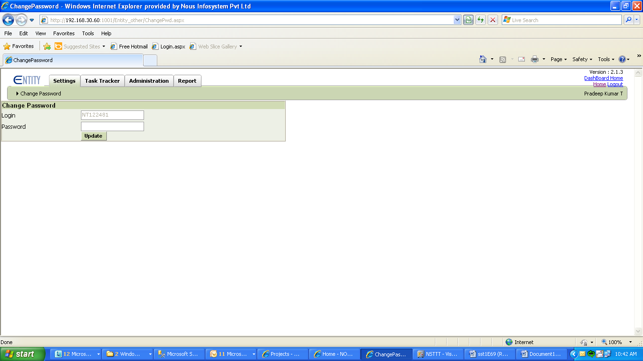

If you have forgotten your password, Press Forgot password link on the login page and follow the instructions. A new password will be sent over email to you.

On days you are on leave apply the same in folklore.Once approved it will reflect in entity.

Please be informed that if you are applying ‘On Duty’, for any given day, Entity will not get updated automatically.

You would need to fill Entity separately for that day with the actual task details you did.